**Seneca** **Polytechnic**

Faculty Toolkit for Student

Group Work

PRACTICAL TOOLS FOR ENHANCING GROUP WORK EFFECTIVNESS



**Melissa Warner, PhD**

**Table of Contents**

**03**

**04**

**06**

**07**

**08**

**09**

**10**

**12**

**13**

**14**

**15**

**16**

**17**

Introduction

Student Recommendations

Best Practices in Student Group Work

Small Groups: What the Research Says

Tools for Faculty:

Faculty Check-In Meeting Sheet

Responsibility Chart

Team Contract

Group Work Necessity Checklist

Student Groupwork Training:

Introduction to Effective Group Work

Assigning Roles and Responsibilities

Building Essential Skills

Monitoring and Reflecting on Group Work

Group Work Reflection Worksheet

**Seneca**

**Polytechnic**





Introduction

This toolkit is designed to help Seneca Polytechnic

faculty enhance the effectiveness of student group

work. Based on findings from a 2024 Seneca Polytechnic research study that examined student group work effectiveness, 12 focus groups were conducted to gather perceptions from faculty, students, and chairs. The insights gathered have informed the following practical recommendations and tools, which are designed to be easily

implemented in the classroom to improve student

engagement and learning outcomes.

**3|**

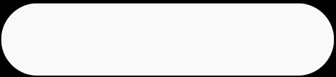**Seneca**

**Polytechnic**

Student Recommendations

**BETTER COORDINATION AMONG PROFESSORS**

**REGARDING DEADLINES TO AVOID BURNOUT**

Students have expressed the need for better coordination between professors to ensure that multiple deadlines are not clustered together, which can lead to increased stress and burnout. A well-distributed schedule allows students to manage their time more effectively and maintain a balance between academic responsibilities and personal well-being.

**STRUCTURED AND DIVERSE GROUP FORMATIONS**

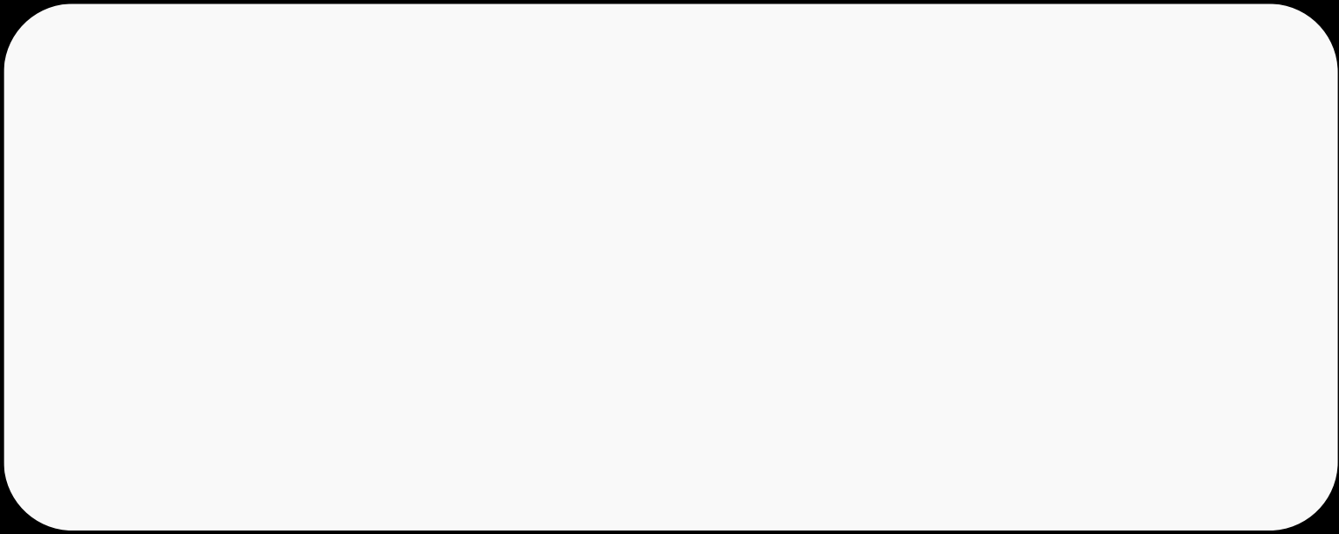

Implementing structured group formation processes can help create diverse groups that promote cultural learning and a variety of perspectives. By mixing students with different backgrounds and experiences, group dynamics can be enriched, leading to a more comprehensive learning experience.

**REGULAR MONITORING AND CHECK-INS BY**

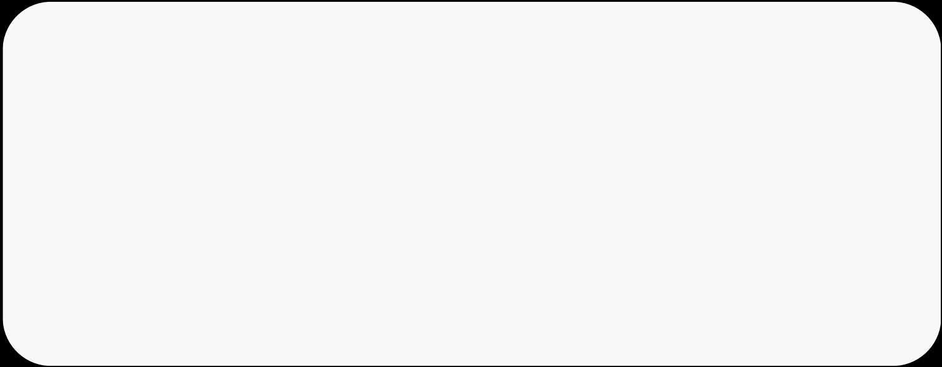**PROFESSORS TO ENSURE FAIR WORKLOAD**

**DISTRIBUTION AND ACCOUNTABILITY**

Regular check-ins and monitoring by professors are crucial to

ensure that all group members are contributing equally and

that any issues are addressed promptly. This helps in maintaining accountability and prevents situations where some students may feel overburdened while others do not participate actively.

**4|**

**Seneca**

**Polytechnic**

Student Recommendations

**ICE-BREAKER ACTIVITIES AND ENFORCED**

**CAMERA USE IN ONLINE SETTINGS**

To foster better communication and interaction, especially in

online settings, incorporating ice-breaker activities can help

students get to know each other and build rapport. Enforcing

the use of cameras during online meetings can also enhance

engagement and make virtual group work more effective.

**MORE IN-CLASS GROUP TIME AND A BALANCED**

**MIX OF INDIVIDUAL AND GROUP ASSIGNMENTS**

Allocating more time for group work within class sessions can

provide students with the opportunity to collaborate more

effectively under the guidance of the professor. Additionally,

balancing group assignments with individual tasks ensures that

students develop both teamwork skills and individual competencies.

**GREATER ACCOUNTABILITY FOR INDIVIDUAL**

**CONTRIBUTIONS AND IMPROVED GROUP**

**FORMATION PROCESSES**

Emphasizing the importance of individual accountability within

group projects can help ensure that all members contribute

their fair share. Clear guidelines and improved processes for

group formation can prevent issues related to group dynamics

and make the experience more equitable and productive for all

participants.

**5|**

Best Practices in Student Group Work

**Seneca**

**Polytechnic** 

Be Strategic About Group Work

Asses if group work is necessary to

meet learning outcomes, especially if

students have multiple group

projects across their courses

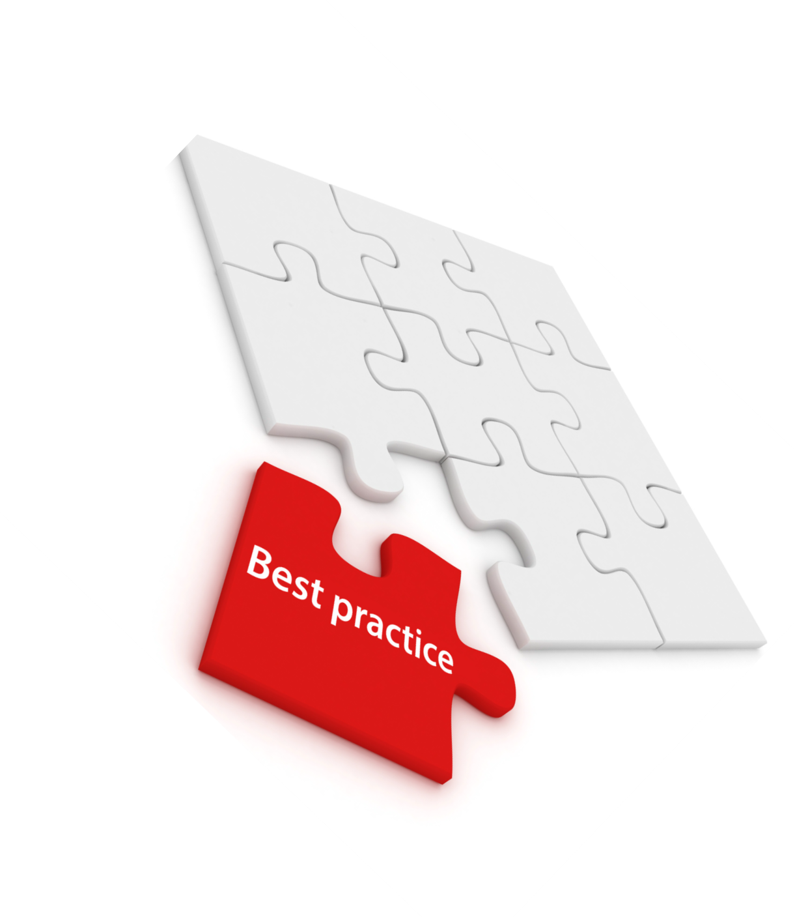Consider reducing the frequency of

group work if not essential

Support Along the Way

Implement milestone due dates

Meet with groups in class at least

once to check progress/provide

support

Strategic Weighing of Group Work

Be thoughtful about how much

group work counts towards the final

grade to ensure it reflects the effort

and learning outcomes

Formative Assessments

Use small in-class group

assignments with the same groups

as the final project to practice and

monitor progress

Keep Groups Small

Opt for smaller paired or individual

assignments

Groups of 2-3 students can

maximize benefits while reducing

challenges

Hybrid Group Formations

Implement a combination of self-

formed and faculty-formed groups

to balance familiarity and diversity

Training on Group Work

Include brief training sessions (15

minutes) on effective group work

strategies and skills

Clarify Roles & Accountability

Have students take ownership of

specific parts of the assignment and

label these parts clearly

Allow flexibility in grading individual

contributions

Hands-On Support Over Tools

Regular check-ins and support are

more effective in reducing social

loafing

Student’s do not take peer

evaluations and contracts seriously;

providing direct support will help

keep things on track



**6|**

SMALL GROUPS: WHAT THE

RESEARCH SAYS

**Seneca**

**Polytechnic**

One study found that smaller groups are more effective in fostering positive interdependence, [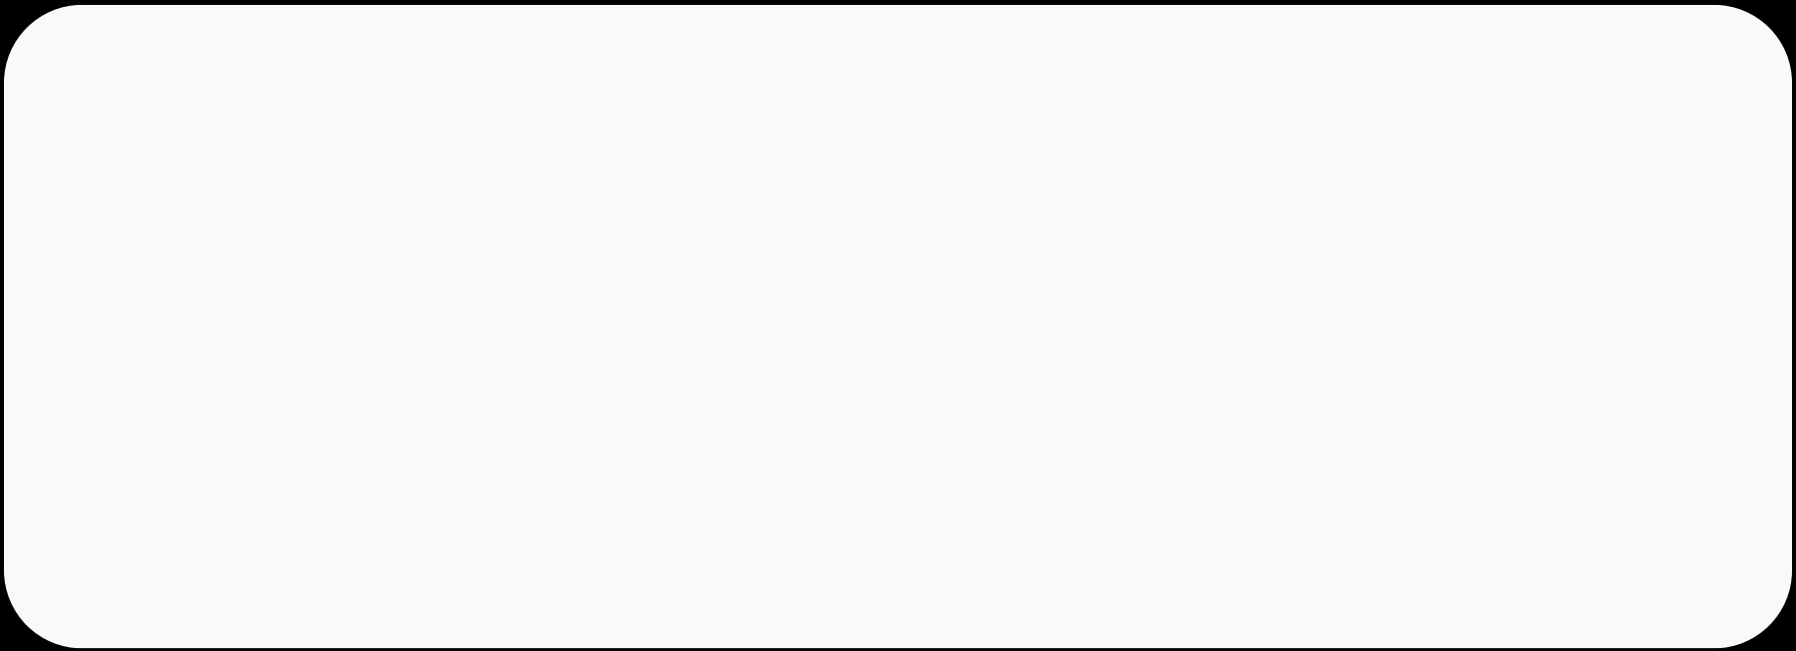](https://journals-sagepub-com.libaccess.senecapolytechnic.ca/doi/full/10.3102/0013189X09339057)individual accountability, and face-to-face interaction, which are key components of successful cooperative learning.

***“Generally, as the group gets larger, members are less likely to see their contributions as*** ***important to the group’s success. Social loafing increases as the group size increases, while*** ***individual accountability decreases.”***

[***Johnson, D. W., & Johnson, R. T. (2009). An Educational Psychology Success Story: Social Interdependence***](https://journals-sagepub-com.libaccess.senecapolytechnic.ca/doi/full/10.3102/0013189X09339057)   
[***Theory and Cooperative Learning. Educational Researcher, 38(5), 365-379.***](https://journals-sagepub-com.libaccess.senecapolytechnic.ca/doi/full/10.3102/0013189X09339057)

Barkley, Cross & Major emphasize that groups should only be as large as necessary to achieve the task, as larger groups can lead to issues with coordination and social loafing.

***“In formal groups working on complex projects, smaller groups are more effective as they*** ***make coordinating logistics easier and reduce the opportunities for social loafing.”***

[***Barkley, E. F., Cross, K. P., & Major, C. H. (2014). Collaborative Learning Techniques: A Handbook for College***](https://ebookcentral-proquest-com.libaccess.senecapolytechnic.ca/lib/senecac/reader.action?docID=1745058&amp;ppg=159&amp;pq-origsite=primo) [***Faculty. John Wiley & Sons.***](https://ebookcentral-proquest-com.libaccess.senecapolytechnic.ca/lib/senecac/reader.action?docID=1745058&amp;ppg=159&amp;pq-origsite=primo)

The study “Social loafing: A meta-analytic review and theoretical integration”, provides an [](https://www.proquest.com/docview/614311782?parentSessionId=QGM92QlSSNAZPiL6OCq0HGdfVK8sYrHzaOz0TCUE6e4%3D&amp;pq-origsite=primo&amp;accountid=28610&amp;sourcetype=Scholarly%20Journals)extensive review of how larger groups can lead to decreased individual accountability and a higher likelihood of social loafing, highlighting the importance of maintaining smaller group sizes to mitigate these risks.

***“Social loafing is reduced when individuals work in smaller groups, where their***

***contributions are seen as unique and essential.”***

[***Karau, S. J., & Williams, K. D. (2020). Social loafing: A meta-analytic review and theoretical integration.***](https://www.proquest.com/docview/614311782?parentSessionId=QGM92QlSSNAZPiL6OCq0HGdfVK8sYrHzaOz0TCUE6e4%3D&amp;pq-origsite=primo&amp;accountid=28610&amp;sourcetype=Scholarly%20Journals) [***Journal of Personality and Social Psychology, 119(2), 336-353.***](https://www.proquest.com/docview/614311782?parentSessionId=QGM92QlSSNAZPiL6OCq0HGdfVK8sYrHzaOz0TCUE6e4%3D&amp;pq-origsite=primo&amp;accountid=28610&amp;sourcetype=Scholarly%20Journals)

**7|**

TOOLS FOR FACULTY

*Feel free to make any necessary adjustments and/or add specific* *rules/guidelines that are relevant to your course and teaching style.*

**FACULTY CHECK-IN** **MEETING SHEET** 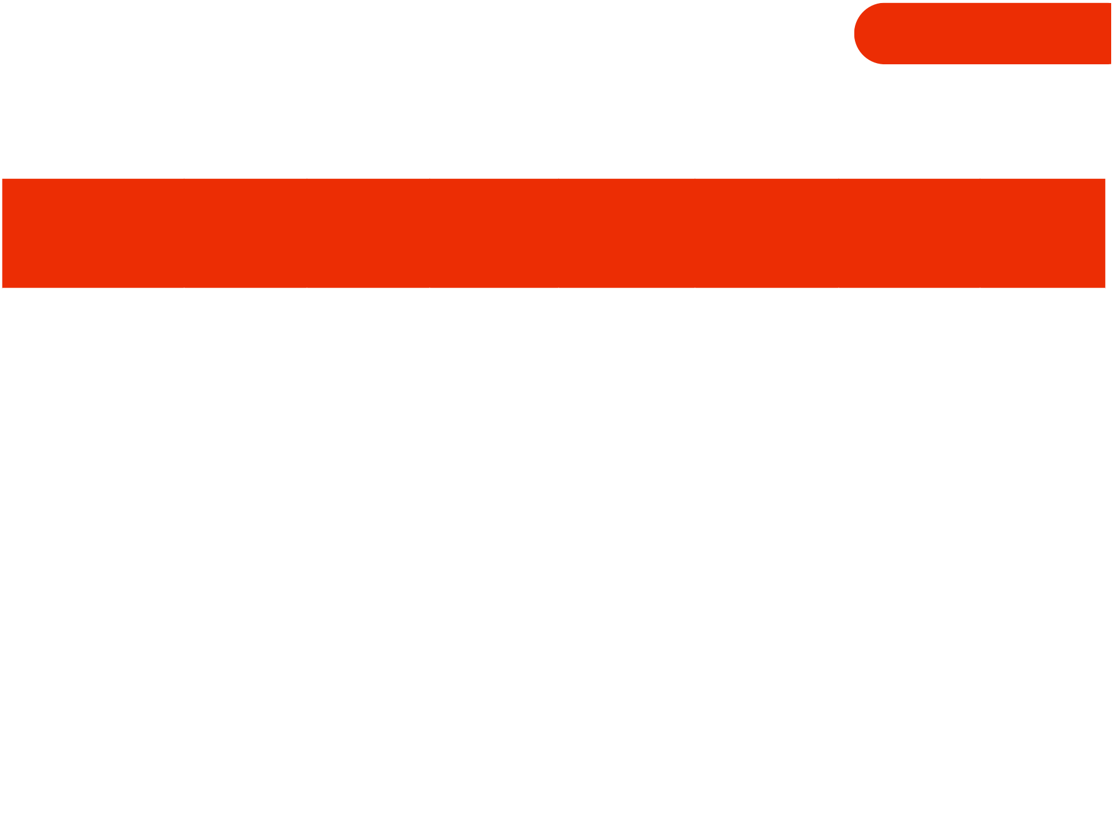

**Seneca**

**Polytechnic**

|  |  |  |  |  |  |  |  |
| --- | --- | --- | --- | --- | --- | --- | --- |
| **Check-In**  **Number** | **Date** | **Group**  **Name** | **Group**  **Members**  **Present** | **Progress**  **Summary** | **Challenges**  **Faced** | **Action**  **Items/Supp**  **ort Needed** | **Faculty**  **Feedback** |
| **INITIAL** |  |  |  |  |  |  |  |
|  |  |  |  |  |  |  |  |
| **MID-PROJECT** |  |  |  |  |  |  |  |
|  |  |  |  |  |  |  |  |
| **FINAL** |  |  |  |  |  |  |  |
|  |  |  |  |  |  |  |  |

*This sheet is designed for faculty to facilitate regular check-ins with student groups*

*on projects worth over 20%. These meetings ensure all team members are on*

*track, address issues promptly, and maintain effective communication and*

*collaboration throughout the project.*

**8|**

TOOLS FOR FACULTY

*Feel free to make any necessary adjustments and/or add specific* *rules/guidelines that are relevant to your course and teaching style.*

**RESPONSIBILITY** **CHART**

**Seneca**

**Polytechnic**

|  |  |  |  |  |
| --- | --- | --- | --- | --- |
| **Task** | **Description** | **Assigned**  **Member(s)** | **Due Date** | **Status (Not**  **Started, In**  **Progress,**  **Completed)** |
| **TASK #1**  **TASK #2**  **TASK #3**  **TASK #4**  **TASK #5**  **TASK #6**  **TASK #7** |  |  |  | |
|  |  |  |  |
|  |  |  |  |
|  |  |  |  |
|  |  |  |  |
|  |  |  |  |
|  |  |  |  |

|  |  |
| --- | --- |
| **Team Member Name** | **Team Member Signature** |
|  |  |
|  |  |
|  |  |
|  |  |

*This chart should be reviewed and updated regularly during team meetings to ensure all*

*tasks are on track and to reassign responsibilities as needed.*

**9|**

|  |  |  |
| --- | --- | --- |
|  | TOOLS FOR FACULTY  *Feel free to make any necessary adjustments and/or add specific* *rules/guidelines that are relevant to your course and teaching style.*  **TEAM** **CONTRACT** | **Seneca**  **Polytechnic** |
| **Team Name:** | **Date:** |
| **PARTICIPATION: WE AGREE TO**  ACTIVELY PARTICIPATE IN ALL GROUP ACTIVITIES, CONTRIBUTE EQUALLY TO THE WORKLOAD, AND RESPECT EACH OTHER'S IDEAS AND CONTRIBUTIONS.  **COMMUNICATION: WE AGREE TO**  COMMUNICATE OPENLY AND FREQUENTLY, RESPOND TO MESSAGES WITHIN 24 HOURS, AND TO USE AGREED UPON PLATFORMS FOR COMMUNICATION (E.G. EMAIL, ZOOM, WHATSAPP, ETC.)  **MEETINGS: WE AGREE TO**  ATTEND ALL SCHEDULED MEETINGS, BE PUNCTUAL AND PREPARED FOR EACH MEETING, AND SET AGENDAS AND DOCUMENT MEETING MINUTES.  **CONDUCT: WE AGREE TO**  MAINTAIN A POSITIVE AND RESPECTFUL ATTITUDE, SUPPORT AND ENCOURAGE ONE ANOTHER, AND ADDRESS ISSUES PROMPTLY AND CONSTRUCTIVELY.  *These are the terms of group conduct and cooperation that we agree on as a team. This contract is agreed upon* *by all team members and will be referred to throughout the project to ensure effective collaboration and*  *successful completion.* **10 |** | |



TOOLS FOR FACULTY

*Feel free to make any necessary adjustments and/or add specific* *rules/guidelines that are relevant to your course and teaching style.*

**TEAM** **CONTRACT**



**Team Name:**

**CONFLICT: WE AGREE TO**

**Seneca**

**Polytechnic**

**Date:** 

ADDRESS CONFLICT PROMPTLY AND RESPECTFULLY, SEEK TO UNDERSTAND DIFFERENT PERSPECTIVES, AND TO ESCALATE UNRESOLVED CONFLICTS TO PROFESSOR.

**DEADLINES: WE AGREE TO**

SET REALISTIC DEADLINES FOR TASKS, COMPLETE TASKS ON OR BEFORE DEADLINE, AND INFORM THE TEAM IN ADVANCE IF UNABLE TO MEET A DEADLINE.

|  |  |
| --- | --- |
| **Team Member Name** | **Team Member Signature** |
|  |  |
|  |  |
|  |  |
|  |  |

*These are the terms of group conduct and cooperation that we agree on as a team. This contract is agreed upon* *by all team members and will be referred to throughout the project to ensure effective collaboration and* *successful completion.*

**11 |**

TOOLS FOR FACULTY

*Feel free to make any necessary adjustments and/or add specific* *rules/guidelines that are relevant to your course and teaching style.*

**GROUP WORK** **NECCISITY CHECKLIST**

**SELF-ASSESSMENT**

**QUESTIONS FOR FACULTY:**



**1. Are students getting group work in other courses?**



**Seneca**

**Polytechnic** 

**2. Will the pros of group work outweigh the cons for this particular assignment?**

**3. What specific outcomes do I want to achieve with group work versus pairs or** **individual assignments, and why?**

**4. Can I achieve the same group work outcomes with an in-class assignment or** **another format?**

**5. Is the group work essential for meeting the learning outcomes, or can it be** **achieved through other means?**



*This tool helps faculty decide if group work is the best approach for a particular assignment by asking* *key questions to assess its necessity and effectiveness.*

**12 |**

Introduction to Effective Group Work

**Objective:**



**Seneca**

**Polytechnic**

Understand the importance of teamwork and the benefits of working in groups.

**ACTIVITY: GROUP NORMS DISCUSSION**

**BREAK STUDENTS INTO SMALL GROUPS.**

**ASK EACH GROUP TO DISCUSS AND LIST 3-5 NORMS THEY BELIEVE ARE**

**ESSENTIAL FOR SUCCESSFUL GROUP WORK (E.G., RESPECTFUL**

**COMMUNICATION, ACTIVE PARTICIPATION).**

**SHARE AND COMPILE A MASTER LIST OF NORMS AS A CLASS.**

Norms Essential for Succeessfull Group Work

**1**

Student Groupwork Training

**2**



**3**

**4**

**5**

**13 |**

Assigning Roles & Responsibilities

**Objective:**



**Seneca**

**Polytechnic**

Learn how to distribute tasks and responsibilities within a group.



**ACTIVITY: ROLE ASSIGNMENT EXERCISE**

**INTRODUCE COMMON GROUP ROLES (E.G., LEADER, EDITOR,**

**COMMUNICATIONS MANAGER,TIMEKEEPER, RESEARCHER).**

**EACH STUDENT SELECTS A ROLE THEY FEEL COMFORTABLE WITH.**

**IN THEIR GROUPS, STUDENTS DISCUSS THEIR ROLES AND HOW THEY WILL**

**CONTRIBUTE TO THE PROJECT.**

**GROUPS PRESENT THEIR ROLE DISTRIBUTION AND JUSTIFY THEIR CHOICES.**

Student Groupwork Training



**14 |**

**Seneca**

**Polytechnic**

**Objective:**



Building Essential Skills

Develop key collaboration skills such as communication, problem-solving, and conflict resolution.



**ACTIVITY: SCENARIO-BASED ROLE PLAY**

**PROVIDE SCENARIOS THAT INVOLVE COMMON GROUP CHALLENGES (E.G.,**

**ONE MEMBER NOT CONTRIBUTING).**

**GROUPS ROLE-PLAY HOW THEY WOULD ADDRESS THESE CHALLENGES USING**

**THE NORMS AND ROLES THEY’VE ESTABLISHED.**

**DEBRIEF WITH THE CLASS ON THE EFFECTIVENESS OF DIFFERENT**

**STRATEGIES USED.**



**SAMPLE SCENARIOS**

**SCENARIO 3:**

Student Groupwork Training

**SCENARIO 1: THE**

**TFhReE EF-rReIDeE-RRider**

**ONE GROUP MEMBER**

**CONSISTENTLY FAILS**

**TO CONTRIBUTE TO**

**MEETINGS OR TASKS,**

**YET EXPECTS TO**

**SHARE EQUALLY IN**

**THE PROJECT’S**

**GRADE. THE GROUP**

**MUST ADDRESS THE**

**ISSUE WITHOUT**

**CAUSING CONFLICT**

**OR RESENTMENT.**

**15 |**

**SCENARIO 2:**

**DOMINANT LEADER**

**A GROUP LEADER**

**MAKES ALL**

**DECISIONS WITHOUT**

**CONSULTING**

**OTHERS, STIFLING**

**COLLABORATION**

**AND CREATIVITY.**

**THE GROUP MUST**

**FIND A WAY TO**

**ENSURE ALL VOICES**

**ARE HEARD WHILE**

**MAINTAINING**

**PRODUCTIVITY.**

**CONFLICT OVER**

**ROLES**

**TWO GROUP**

**MEMBERS WANT THE**

**SAME ROLE, LEADING**

**TO TENSION AND AN**

**IMPASSE. THE GROUP**

**MUST NAVIGATE THE**

**DISAGREEMENT AND**

**ALLOCATE ROLES IN**

**A WAY THAT**

**SATISFIES EVERYONE**

**AND KEEPS THE**

**PROJECT MOVING**

**FORWARD.**

**Seneca**

**Polytechnic**

**Objective:**

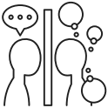

Monitoring and Reflecting on Group Work

Reflect on group performance and identify areas for

improvement.



**ACTIVITY: GROUP REFLECTION SESSION**

**AT THE END OF THE PROJECT, HAVE GROUPS MEET TO DISCUSS WHAT**

**WORKED WELL AND WHAT DIDN’T.**

**USE A REFLECTION WORKSHEET WHERE EACH MEMBER WRITES ONE**

**STRENGTH AND ONE AREA FOR IMPROVEMENT FOR THE GROUP.**

**THIS WORKSHEET ENCOURAGES INDIVIDUAL REFLECTION AND GROUP**

**DISCUSSION, HELPING STUDENTS IDENTIFY STRENGTHS AND AREAS FOR**

**IMPROVEMENT, BOTH INDIVIDUALLY AND AS A GROUP.**

**AFTER COMPLETING THE INDIVIDUAL REFLECTION, ENSURE THAT EACH**

**GROUP DISCUSSES THE KEY POINTS COLLECTIVELY AND TAKES NOTES ON**

**THE MAIN OUTCOMES OF THE DISCUSSION.**

**GROUPS SHARE THEIR REFLECTIONS, AND THE CLASS DISCUSSES GENERAL**

**TRENDS AND TAKEAWAYS FOR FUTURE PROJECTS.**

Student Groupwork Training



**16 |**

**Seneca**

**Polytechnic**



Monitoring and Reflecting on Group Work

**Group Reflection Worksheet**

**Instructions:** Each member of the group should individually

reflect on their group’s performance. For each question, write

down your thoughts and then discuss them as a group.

GROUP STRENGHTS

Reflect on one strength that your group exhibited during the project. This could be

related to collaboration, communication, problem-solving, or any other aspect of

the group’s work.

My Group’s Strength:

AREA FOR IMPROVEMENT

Identify one area where your group could improve. Consider aspects like time

management, role distribution, or conflict resolution.

Area for Improvement:

PERSONAL CONTRIBUTION

Reflect on your personal contribution to the group. What did you do well, and what

could you improve for future group work.

My Contribution:

ACTION PLAN

Based on the reflection, write down one action you or the group could take to

address the area for improvement in future projects.

Action Plan:

Student Groupwork Training

**17 |**