Faronics Insight

To use Insight, **the students must use Microsoft Edge.** The files are:

## AI_FF_GC.json

This file blocks popular AIs, Firefox, and Google Chrome. The students have access to the entire world but not AIs.

## AI_FF_GC_MSO.json

This file blocks popular AIs, Firefox, Google Chrome, and all Microsoft Office (MSO) applications (such as Word, Excel, and PowerPoint). However, if the MSO file is embedded in Blackboard, the browser can open it. The students have access to the entire world but not AIs.

## AI_FF_GC_MSO_SE.json

This file blocks popular AIs, Firefox, Google Chrome, all Microsoft Office (MSO) applications (such as Word, Excel, and PowerPoint), and popular Search Engines. However, if the MSO file is embedded in Blackboard, the browser can open it. The students can access the entire world, not just AIs and search engines.

## ITAS_Labs_FF_GC_MSO.json

This file gives students access to login and use Blackboard and MyApps. They can run Packet Tracer and authenticate with Netacad.com.

This file blocks popular AIs, Firefox, Google Chrome, all Microsoft Office (MSO) applications (such as Word, Excel, and PowerPoint), and popular Search Engines. However, if the MSO file is embedded in Blackboard, the browser can open it.

# The list of applications and URLs that blocked:

### The URLs for the popular search engines:

1. Google: [https://www.google.com]

2. Bing: [https://www.bing.com]

3. Yahoo!: [https://www.yahoo.com]

4. DuckDuckGo: [https://www.duckduckgo.com]

5. Baidu: [https://www.baidu.com]

6. Yandex: [https://www.yandex.com]

7. Ecosia: [https://www.ecosia.org]

8. Ask.com: [https://www.ask.com]

9. AOL Search: [https://search.aol.com]

10. StartPage: [https://www.startpage.com]

### The executable file names for the main Microsoft Office applications:

1. Microsoft Word: `winword.exe`

2. Microsoft Excel: `excel.exe`

3. Microsoft PowerPoint: `powerpnt.exe`

4. Microsoft Outlook: `outlook.exe`

5. Microsoft Access: `msaccess.exe`

6. Microsoft Publisher: `mspub.exe`

7. Microsoft OneNote: `onenote.exe`

8. Microsoft Teams: `teams.exe`

9. Microsoft Skype for Business: `lync.exe`

10. Microsoft Visio: `visio.exe`

11. Microsoft Project: `winproj.exe`

### The list of AI's URLs:

https://www.openai.com

https://ai.google

https://www.microsoft.com/en-us/ai

https://www.ibm.com/watson

https://deepmind.com

https://arxiv.org

https://scholar.google.com

https://www.microsoft.com/en-us/research

https://www.alignmentforum.org

https://www.kaggle.com

https://www.tensorflow.org

https://pytorch.org

https://scikit-learn.org

https://www.fast.ai

https://huggingface.co

https://cloud.google.com/products/ai

https://aws.amazon.com/machine-learning

https://azure.microsoft.com/en-us/services/machine-learning

https://opencv.org

https://spacy.io

https://www.nltk.org

https://radimrehurek.com/gensim

https://openai.com/dall-e

https://runwayml.com

https://ainowinstitute.org

https://futureoflife.org

https://www.partnershiponai.org

https://alignmentforum.org

https://ai.stackexchange.com

https://www.reddit.com

https://www.icml.cc

https://neurips.cc

# How to import and edit the settings:

You can click on Settings on the menu and choose “Import Settings”. If you want to add or remove anything from the fields, click on the gear sign in front of the imported file.

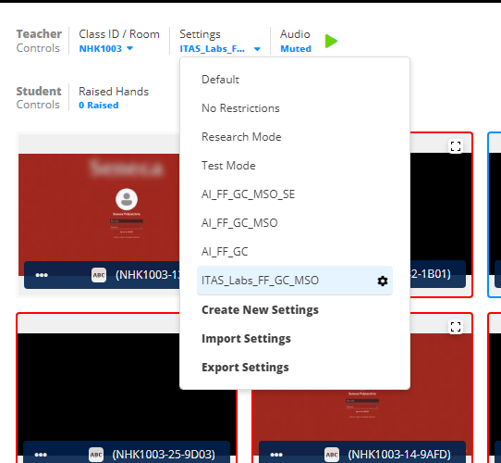

For adding applications, under Block Applications, I added Blocked ones. You can remove them from the list. If you want to add a new application, click on “Add Application” and just put the executable file of the application (like, excel.exe).

For adding a URL, under “Web Filtering, put the URL in the box and add it.

